Chemistry 115 Name ______________________________
Quiz 2a
Dr. Cary Willard September 3, 2013

All work must be shown to receive credit. Use correct significant figures. $℃=\frac{℉-32}{1.8} , ℉=1.8℃+32, K=℃+273$

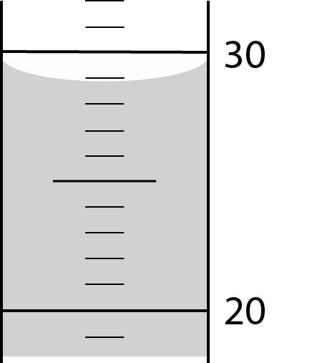
- (4 points) What is the volume of liquid in the graduated cylinder at the right? (The cylinder is calibrated in mL)

- (6 points) Complete the following conversions
  - 38.6 cm to m

  - 73.2 kg to lb

- (5 points) How many days would it take for a crepe myrtle tree to grow 5.00 cm in height if it grows 4.27 feet per year?

- (5 points) Make the following temperature conversions
  - 84ºF to ºC

  - 52º C to K

Chemistry 115 Name ______________________________
Quiz 2b
Dr. Cary Willard September 3, 2013

All work must be shown to receive credit. Use correct significant figures. $℃=\frac{℉-32}{1.8} , ℉=1.8℃+32, K=℃+273$

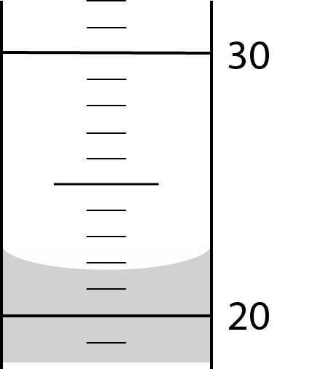
- (4 points) What is the volume of liquid in the graduated cylinder at the right? (The cylinder is calibrated in mL)

- (6 points) Complete the following conversions
  - 95.4 cm to m

  - 73.2 kg to lb

- (5 points) How many days would it take for a crepe myrtle tree to grow 8.00 cm in height if it grows 4.27 feet per year?

- (5 points) Make the following temperature conversions
  - 61ºF to ºC

  - 88º C to K

Chemistry 115 Name ______________________________
Quiz 2c
Dr. Cary Willard September 3, 2013

All work must be shown to receive credit. Use correct significant figures. $℃=\frac{℉-32}{1.8} , ℉=1.8℃+32, K=℃+273$

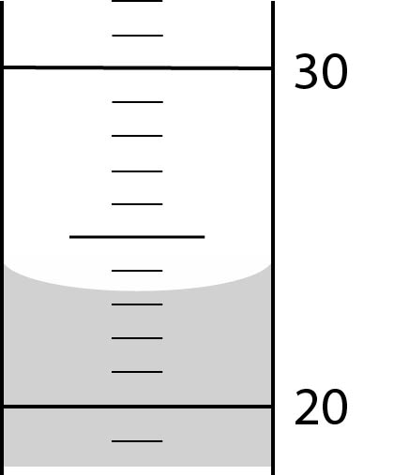
- (4 points) What is the volume of liquid in the graduated cylinder at the right? (The cylinder is calibrated in mL)

- (6 points) Complete the following conversions
  - 0.571 kg to g

  - 64.2 qt to L

- (5 points) How many days would it take for a crepe myrtle tree to grow 5.00 cm in height if it grows 6.48 feet per year?

- (5 points) Make the following temperature conversions
  - 24ºC to ºF

  - 63º C to K

Chemistry 115 Name ______________________________
Quiz 2d
Dr. Cary Willard September 3, 2013

All work must be shown to receive credit. Use correct significant figures. $℃=\frac{℉-32}{1.8} , ℉=1.8℃+32, K=℃+273$

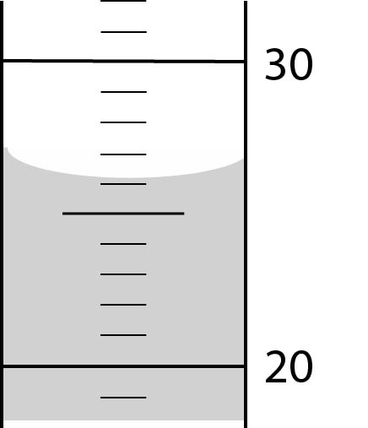
- (4 points) What is the volume of liquid in the graduated cylinder at the right? (The cylinder is calibrated in mL)

- (6 points) Complete the following conversions
  - 0.672 kg to g

  - 32.9 qt to L

- (5 points) How many days would it take for a crepe myrtle tree to grow 8.00 cm in height if it grows 6.48 feet per year?

- (5 points) Make the following temperature conversions
  - 41ºC to ºF

  - 29º C to K

